

[Bio](https://www.qualitydigest.com/users/quality-technology-corner-john-flaig)

Six Sigma

A Bell-Shaped Distribution Does Not Imply Only Common Cause Variation

Some practitioners think that if data from a process have a “bell-shaped” histogram, then the system is experiencing only common cause variation (i.e., random variation). This is incorrect and reflects a fundamental misunderstanding about the relationship between distribution shape and the variation in a system. However, even knowledgeable people sometime make this mistake.

|  |
| --- |
|  |

For example, paraphrasing from a popular Six Sigma textbook, when most values fall in the middle and tail off in either direction, we have statistical evidence of common cause variation.1,2 This is an invalid statement, and the misunderstanding probably stems from the fact that if we were sampling means from a stable process, the central limit theorem would assure us that the distribution of sample means would be approximately normally distributed. However, even though the histogram of the subgroup means is bell-shaped, the process itself may still be non-normal or be experiencing special or systematic causes of variation (i.e., it may be out-of-control). To determine the correct status of the process, we must look at the control chart of the individual observations, not the distribution of subgroup means.

The fact that a “normal” distribution shape does not imply process stability is known as the Quetelet Fallacy and is documented in *The History of Statistics.*3 You may be surprised to learn that many educated people, including statisticians and engineers, have no knowledge of the fallacy or believe it to be true, and that the belief in the fallacy has a long history. The first documented example that it is false was given in Sir Frances Galton’s famous sweet pea experiment of 1875 that exposed the Quetelet conjecture as false.4

A proof is given below for the argument that a normal or bell-shaped histogram does not imply that the system is experiencing only common cause variation, and conversely a system experiencing only common cause variation will not necessarily have a normal distribution of observations.

**Theorem:** Normal does not imply Random, and Random does not imply Normal  
**Proof:**  
Part 1. The proof that “Random does not imply Normal” is obvious because you can generate random (i.e., common cause) distributions that are uniform, triangular, Weibull, Poisson, Cauchy, etc., and yes, even Normal (see JMP or Minitab for examples). Also, Walter A. Shewhart’s figure 9 in his 1931 book, *Economic Control of Quality of Manufactured Product*, contains an example. It is the histogram of the modulus of rupture for sitka spruce trees. The histogram is skewed, but Shewhart observes that it is at least approximately in a state of statistical control.5

Part 2. The proof that “Normal does not imply Random” is false is illustrated by a counter example given below. In this example the histogram is bell-shaped, but the system is experiencing both special cause (in this case systematic) variation and common cause (i.e., random) variation. In the graph the slope of the polynomial trend line characterizes special cause (systematic) variation, and common cause (random) variation is characterized by the spread of the points about the trend line.

**Example:**   
**Clothing sales data** for spring, summer, and fall (× 1,000 units)  
{1, 2, 3, 3, 4, 4, 4, 5, 5, 5, 5, 5, 6, 6, 6, 7, 7, 8, 9}  
**Period 1:** May, June (six weeks, new marketing dialog)   
**Period 2:** July, August (seven weeks, old marketing dialog)   
**Period 3:** September, October (six weeks, new marketing dialog)

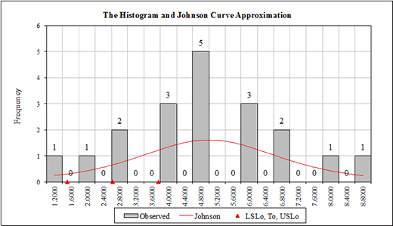  
Histogram of the sales data

The graph of the sales over time shows the effect of the marketing programs in the spring and fall. This change in performance was caused by systematic changes in the process (i.e., the marketing initiatives) and not just random variation.

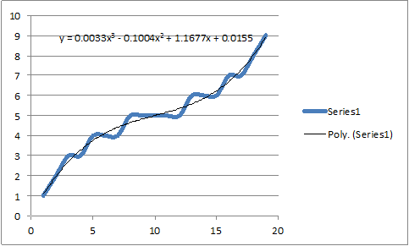  
Plot of sales performance over time

Irrespective of the shape of the distribution, a good way to arrive at the correct conclusion regarding process stability is by looking at a control chart of the behavior of the individual observations from the process, or for highly skewed distributions, by using the F* test6 [Cruthis, 1993] or the Dixon and Massey z-test7 where z ~ N(0, 1) and is given by:  
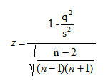  
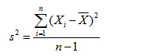  
https://www.qualitydigest.com/IQedit/Images/Articles_and_Columns/2017/08_Aug-2017/Flaig/working_clip_image008.jpg  
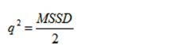

**References**  
1. Eckes, G. [*The Six Sigma Revolution*](http://www.wiley.com/WileyCDA/WileyTitle/productCd-047138822X.html)*.* New York: John Wiley & Sons, 2001, pg. 97.   
2. Eckes, G. [*Six Sigma for Everyone*](http://www.wiley.com/WileyCDA/WileyTitle/productCd-0471281565.html)*.* New York: John Wiley & Sons, 2003, pp. 72, 73.   
3. Stigler, S. M. [*The History of Statistics*](http://www.hup.harvard.edu/catalog.php?isbn=9780674403413). Cambridge, MA: The Belknap Press of Harvard University Press, 1986.  
4. Wheeler, D. J. personal communications, 2016.  
5. Shewhart, W. A. [*Economic Control of Quality of Manufactured Product*](http://asq.org/quality-press/display-item/index.html?item=H0509&xvl=76BK_H0509)*.* New York: D. Van Nostrand, 1931. (Republished in 1980 by the American Society for Quality Control, Milwaukee, WI.)  
6. Cruthis, E. N. and S. E. Rigdon. [“Comparing Two Estimates of Variance to Determine the Stability of a Process,”](http://asq.org/qic/display-item/index.html?item=11877) *Quality Engineering,* vol. 5, no. 1., 1993.  
7. Dixon, W. J. and F. J. Massey. [*Introduction to Statistical Analysis*](https://www.amazon.com/Introduction-Statistical-Analysis-WILFRID-MASSEY/dp/0070170703). New York: McGraw-Hill, 1969.

About The Author



John Flaig

*John J. Flaig, Ph.D., is a fellow of the American Society for Quality and is managing director of Applied Technology at*[*www.e-at-usa.com*](http://www.e-at-usa.com/index.htm)*, a training and consulting company. Flaig has given lectures and seminars in Europe, Asia, and throughout the United States. His special interests are in statistical process control, process capability analysis, supplier management, design of experiments, and process optimization. He was formerly a member of the Editorial Board of Quality Engineering, a journal of the ASQ, and associate editor of Quality Technology and Quantitative Management, a journal of the International Chinese Association of Quantitative Management.*